

**DEPARTMENT OF COMPUTER SCIENCE**

**AND APPLICATIONS**

**IBM PROJECT REPORT**

**HOTEL MANAGEMENT**

*Submitted by*

*ALFI JAMES (222312119)*

*NITHYAA SRI. S (222312126)*

*SWATHI. A (222312128)*

**BACHELOR OF SCIENCE IN COMPUTER**

**SCIENCE WITH ARTIFICIAL INTELLIGENCE**

*Under the guidance of*

*SUBHA SRI. S - Corporate Trainer*

**2023 - 2024**

**DECLARATION**

We, **Alfi James, Nithyaa Sri. S and Swathi. A** hereby declare that this project report on **“**Analysing hotel management system data using COGNOS tool” submitted to University of Madras in partial fulfilment of the requirement for the award of the Degree Bachelor of computer science with Artificial Intelligence under the guidance of **DR.G.MONIKA M.Sc., PhD., HEAD OF DEPARTMENT** and **SUBHA SRI. S** has not been submitted earlier to any other university or institute for the award of any degree.

**ALFI JAMES**

**NITHYAA SRI. S**

**SWATHI. A**

**Place:**

**Date:**

**BONAFIDE CERTIFICATE**

This is to certify that the project titled “Analysing hotel management system data using COGNOS tool”is the bonafide work done by , **Alfi James, Nithyaa Sri. S and Swathi. A** hereby and first year student of Jeppiaar College of Arts and Science , Padur, Chennai in partial fulfilment of the requirment for the award of the Degree of Bachelor of computer Science with Artificial Intelligence 2023-2024.

**PROJECT GUIDE: SUBHA SRI. S**

**HEAD OF THE DEPARTMENT:**

**Date:**

|  |  |  |
| --- | --- | --- |
| **S. No** | **INDEX** | **Page No** |
| 1. | INTRODUCTION |  |
| 2. | ABSTRACT |  |
| 3. | REPORTS   1. HOTEL DATABASE AS LIST 2. ADULTS ASSIGNED BY ROOM TYPE 3. NO. OF. ADULTS IN COUNTRY 4. NO. OF. PEOPLE STAYS IN WEEKEND NIGHTS 5. NO. OF. PEOPLE STAYS IN WEEKEND NIGHTS BY COUNTRY WISE |  |
| 4. | FINNAL DASH BOARD |  |
| 5. | CONCLUTION |  |
| 6. | REFERENCE |  |

**INTRODUCTION:**

Our project focuses on leveraging IBM COGNOS Analytics for analyzing hotel management data. With COGNOS' versatile toolbox including List, Text Item, Block, Table, Crosstab, and Visualization features, we delve into data exploration and analysis. By uncovering trends and patterns, we aim to enhance operational efficiency and elevate the guest experience in the hospitality industry. Join us as we utilize COGNOS to extract actionable insights and drive informed decision-making in hotel management.

Top of Form

Top of Form

**ABSTRACT:**

This project explores the utilization of IBM COGNOS Analytics for analyzing hotel management data, aiming to enhance operational efficiency and elevate the guest experience in the hospitality industry. Leveraging COGNOS' versatile toolbox, including List, Text Item, Block, Table, Crosstab, and Visualization features, we delve into data exploration and analysis. Through uncovering trends and patterns, actionable insights are extracted to drive informed decision-making. Join us on this journey as we showcase the power of COGNOS in unlocking the potential for strategic decision-making and operational excellence in hotel management.

**REPORTS:**

Top of Form

1. **HOTEL DATABASE AS LIST:**

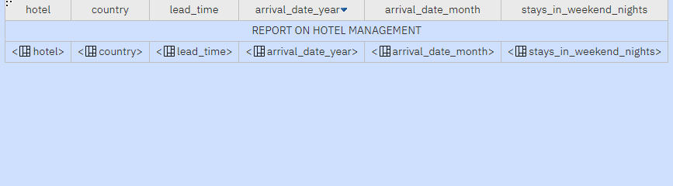

**OUTPUT:**

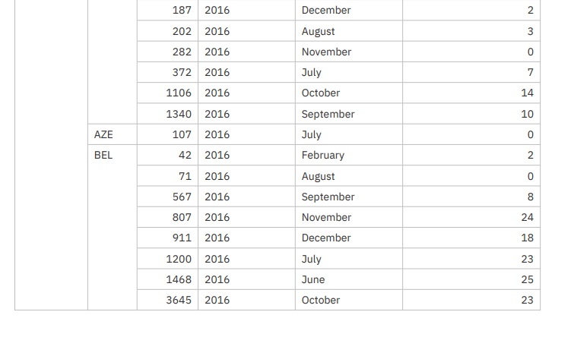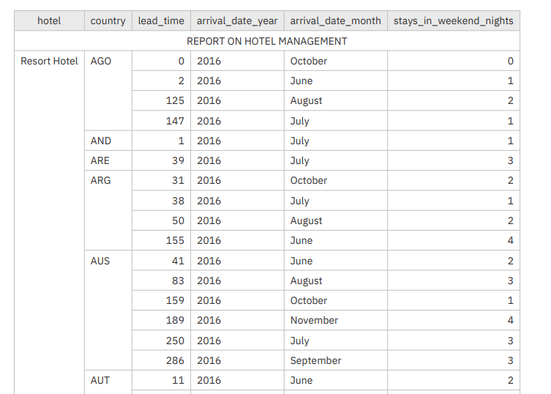

1. **ADULTS ASSIGNED BY ROOM TYPE:**

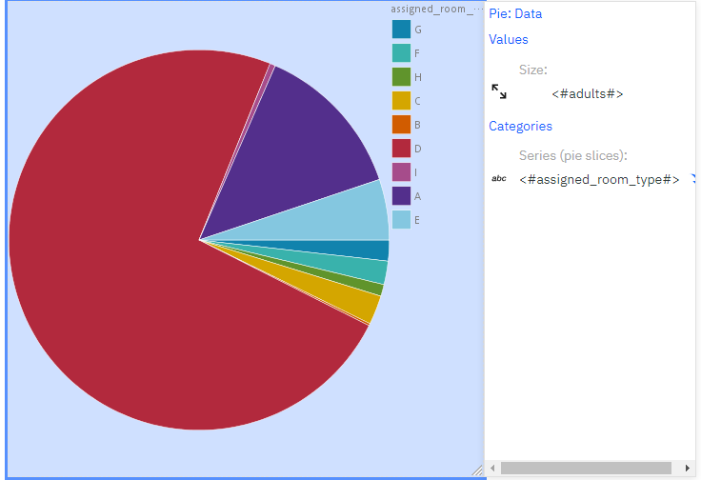

1. *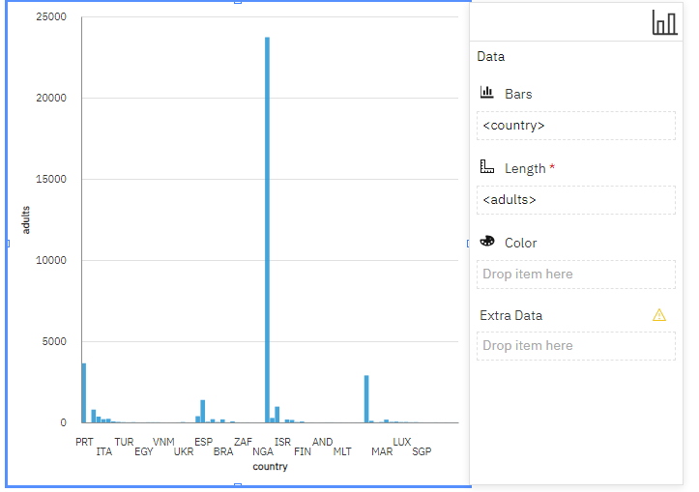***NO. OF. ADULTS IN COUNTRY *:***
2. **NO. OF. PEOPLE STAYS IN WEEKEND NIGHTS:**

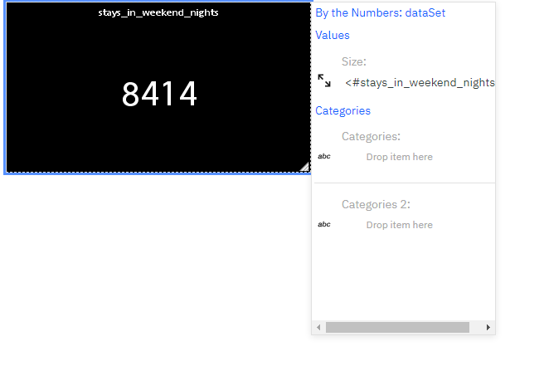

1. *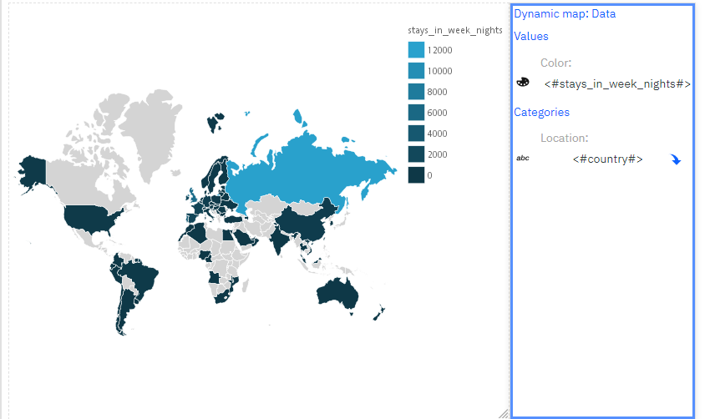***NO. OF. PEOPLE STAYS IN WEEK NIGHTS BY COUNTRY WISE :**

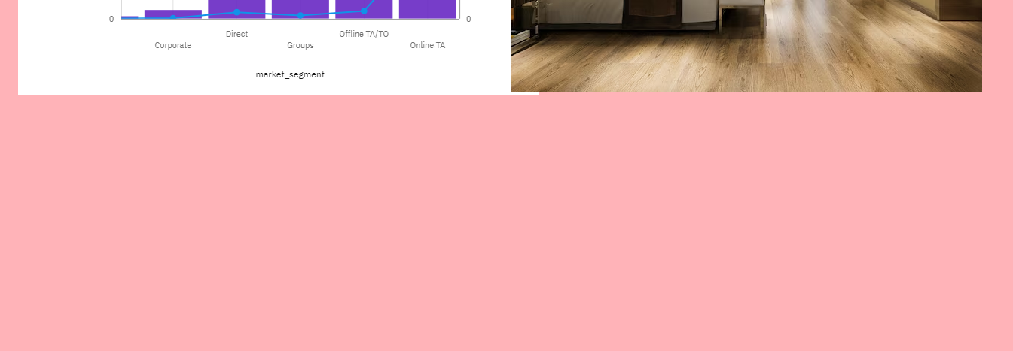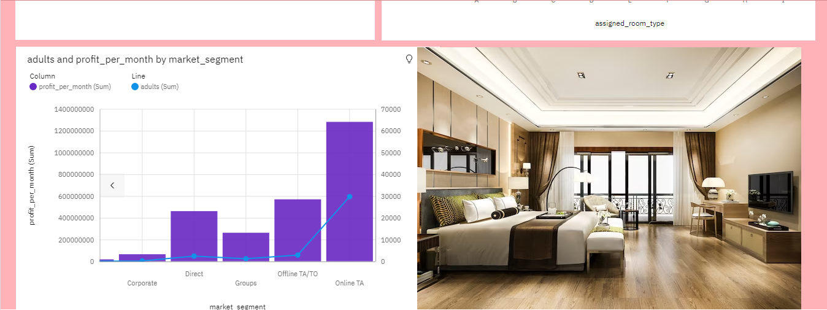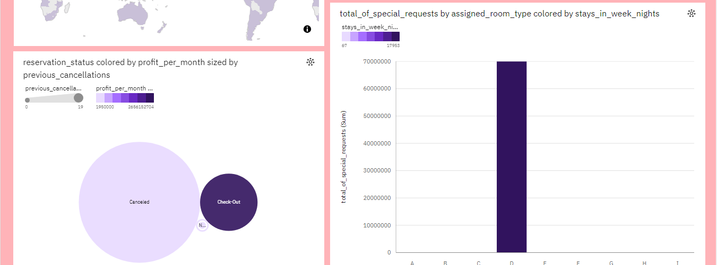**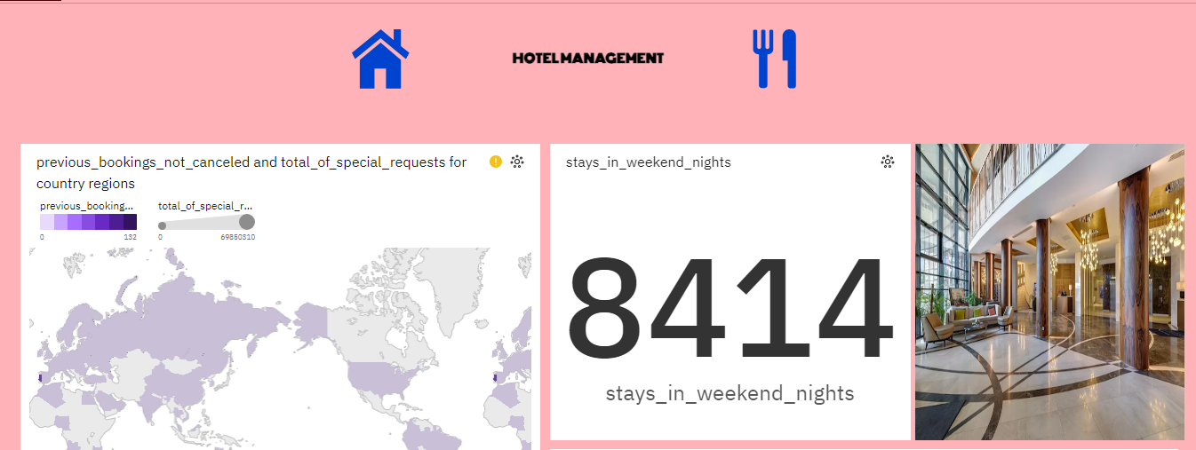FINAL DASH BOARD OF HOTEL MANAGEMENT:**

**DASH BOARD LINK:**

[**https://us1.ca.analytics.ibm.com/bi/?perspective=dashboard&pathRef=.my_folders%2FHOTEL%2BMANAGEMENT%2Bdashboard&action=view&mode=dashboard&subView=model0000018e9e2ce7f8_00000000**](https://us1.ca.analytics.ibm.com/bi/?perspective=dashboard&pathRef=.my_folders%2FHOTEL%2BMANAGEMENT%2Bdashboard&action=view&mode=dashboard&subView=model0000018e9e2ce7f8_00000000)

**CONCLUTION:**

Our project has used IBM COGNOS Analytics to study hotel data better. We've explored different parts of the data using tools like lists, tables, and visualizations. By doing this, we've found trends and patterns that help hotels run more smoothly and make guests happier. This shows how important it is to use data to make smart decisions in the hotel industry.

Our work is just the beginning. We'll keep using COGNOS Analytics to find even more ways to improve how hotels work and how guests feel during their stay. Come join us as we keep making hotels better with the help of data!

**REFERENCE**:

<https://us1.ca.analytics.ibm.com/bi/?perspective=home>

<https://www.kaggle.com/datasets/jessemostipak/hotel-booking-demand>